[WORKING WITH THE DATASET](https://careereducation.smartinternz.com/Student/guided_project_workspace/10708#collapse1)

Loading the Dataset

Open Cognos Analytics and click upload data

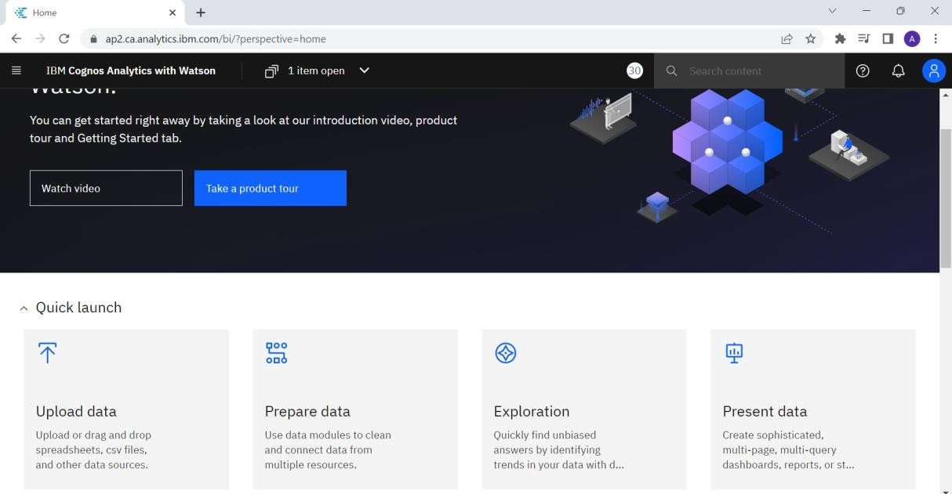

Select the dataset to be uploaded

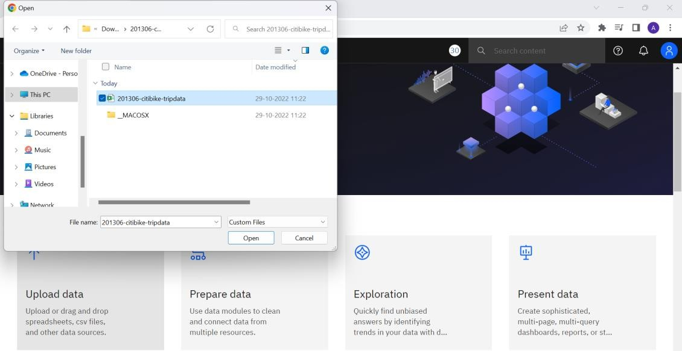

The excel file is getting uploaded in Cognos Analytics

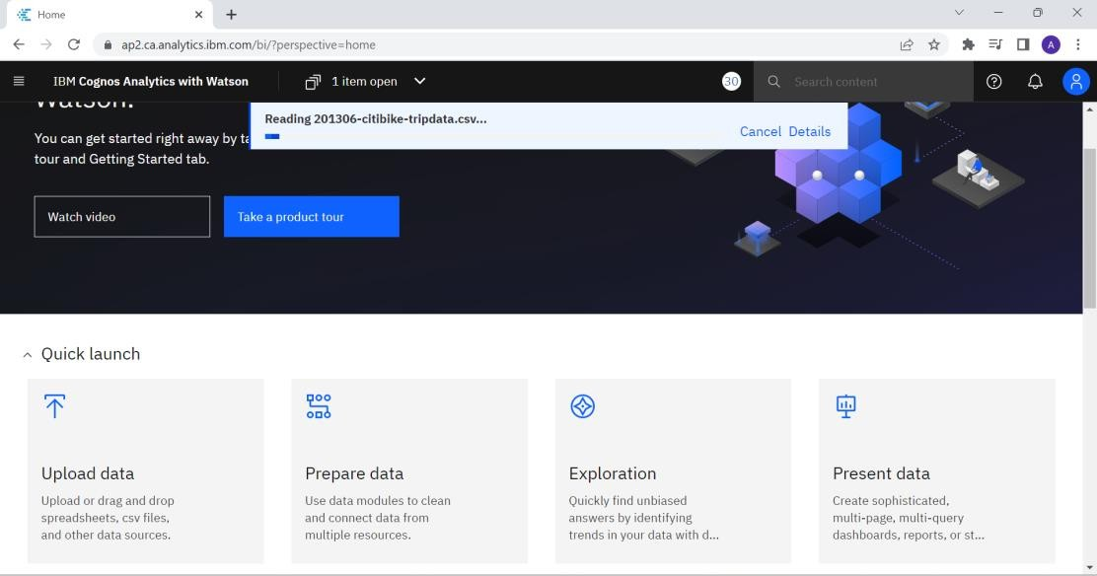

The dataset can be accessed in My Content in Cognos Analytics

